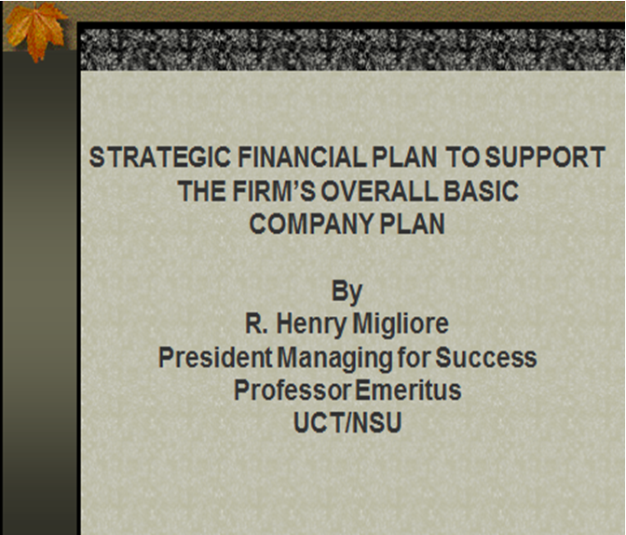

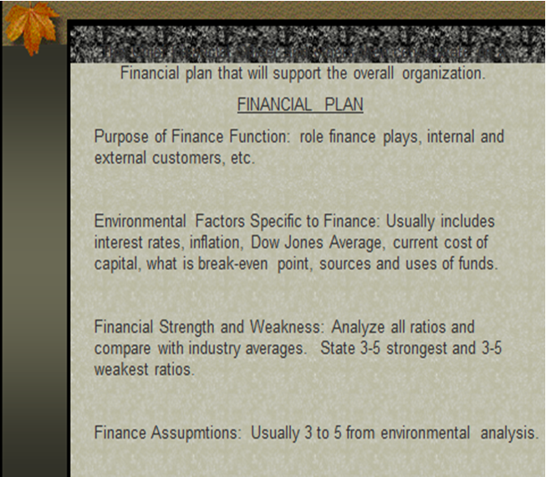

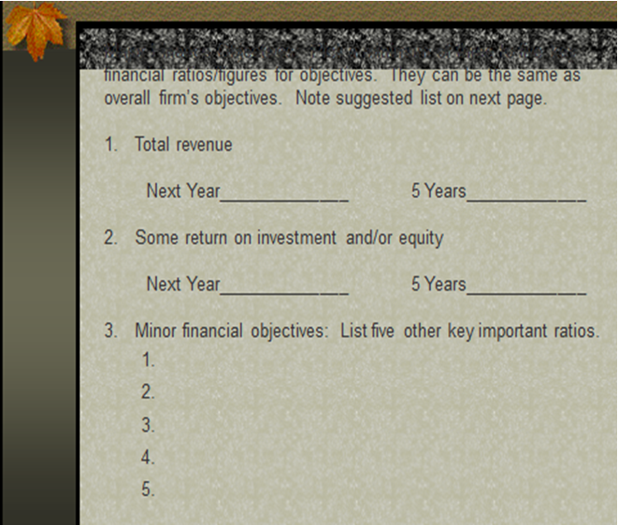

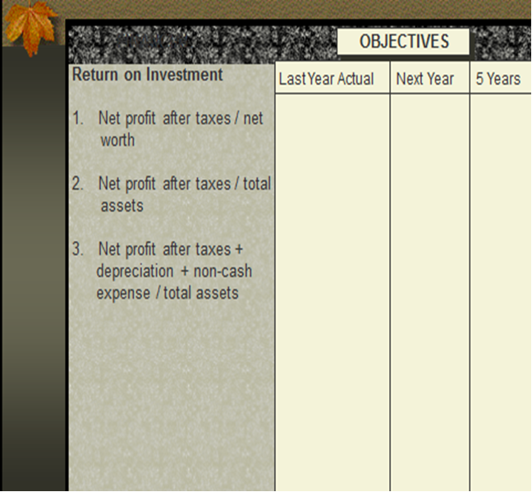

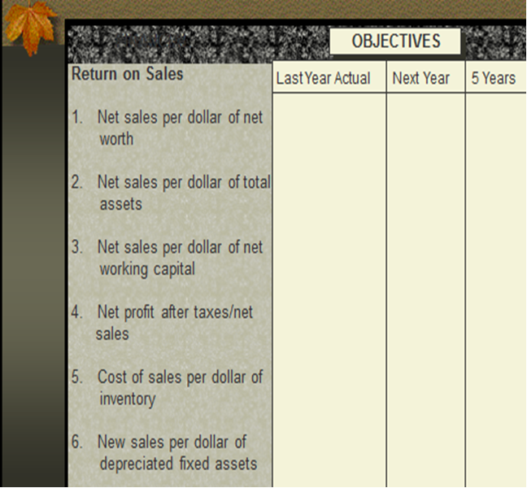

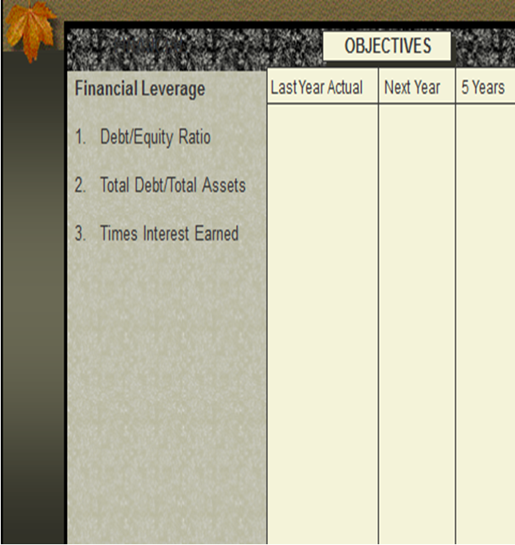

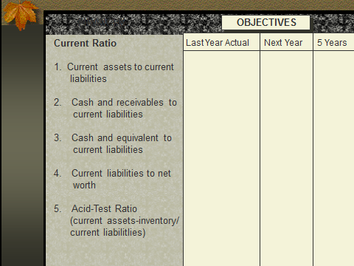

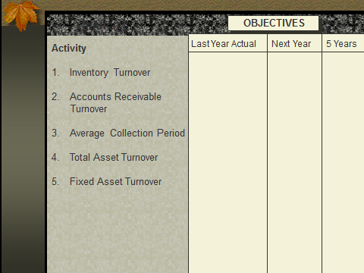

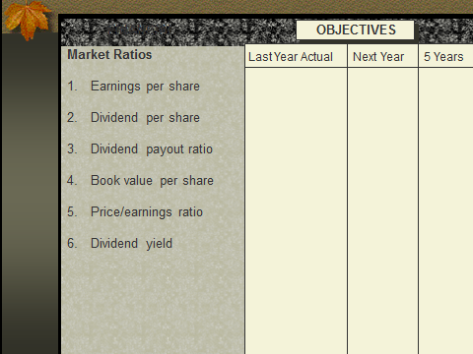

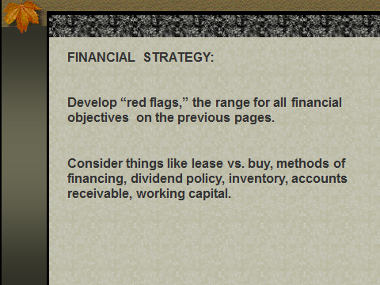

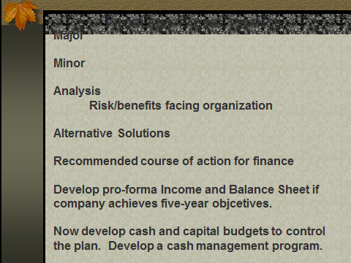
WORKSHEET
STRATEGIC FINANCIAL PLAN TO SUPPORT
THE FIRM'S OVERALL BASIC COMPANY PLAN

by
R. Henry Migliore

OUTLINE

The organization's overall strategic plan is developed according to the following format. The Production Manager, as part of the organization's top management team, has played a vital and integral role in developing this overall plan.

- Purpose
  - What is "reason for being," your "mission," why products are needed, customers served, needs met in marketplace, and scope of the endeavor?
  - Nationwide and/or local, ethics, profit, or nonprofit.

- Environmental Analysis
  - Pulse
  - Now or past
  - Industry surveys
  - Completed studies of future done now

- Strengths and Weaknesses (S & W) (usually internal)
  - Human
  - Facilities/equipment
  - Patents/resources natural
  - Financial

- Assumptions
  - Have no control over
  - Extend environmental analysis
  - Usually external

- Objectives and Goals
Specific time frame, objectives, and goals including specific time frames measurable in key result areas. Note all rules for objectives in chapter 8 of Migliore's book Strategic Planning and chapters in Strategic Planning and Management. Usually total revenue, some measure of return on investment, and/or equity are included in overall plan.
- Strategy—Two to three strategies for each objective: Thinking stage, Where and how to commit resources, Timing, Pricing policy
  - Sales/Marketing
  - Manufacturing
  - Financial: Major broad financial strategy stated here
  - Facilities: People/training/morale/public responsibility
  - Merger, partnership, acquisition, corporation, joint venture. The overall organization plan also includes problems, alternatives, and recommendations. The size of the organization and scope are major factors to be considered in developing the financial plan.

The Chief Financial Officer and others then concentrate on a financial plan that will support the overall organization.

Financial Plan

Purpose of Finance Function: Role finance plays, internal and external customers, etc.

Environmental Factors Specific to Finance: Usually includes interest rates, inflation, Dow Jones Average, current cost of capital, what is break-even point, sources and uses of funds.

Financial Strength and Weakness: Analyze all ratios and compare with industry averages. State three to five strongest and three to five weakest ratios.

Finance Assumptions: Usually three to five from environmental analysis.

Major Finance Objectives: Pick a minimum of three to five key financial ratios/figures for objectives. They can be the same as overall firm's financial objectives. Note suggested list on next page.

- Total revenue

Next Year 5 Years

- Some return on investment and/or equity
Next Year 5 Years

- Minor Financial Objectives: List five other key important ratios.

FINANCIAL

 | OBJECTIVES
 | Last Year Actual | Next Year | 5 Years
Return on Investment
- Net profit after taxes/net worth
- Net profit after taxes/total assets
- Net profit after taxes + depreciation + non-cash expense/total assets

Return on Sales
- Net sales per dollar of net worth
- Net sales per dollar of total assets
- Net sales per dollar of net working capital
- Net profit after taxes/net sales
- Cost of sales per dollar of inventory
- New sales per dollar of depreciated fixed assets

Financial Leverage
- Debt/Equity Ratio
- Total Debt/Total Assets
- Times Interest Earned

Current Ratio
- Current assets to current liabilities
- Cash and receivables to current liabilities
- Cash and equivalent to current liabilities
- Current liabilities to net worth
- Acid-Test Ratio (current assets-inventory)/current liabilities)

Activity
- Inventory Turnover
- Accounts Receivable Turnover
- Average Collection Period
- Total Asset Turnover
- Fixed Asset Turnover

Market Ratios
- Earnings per share
- Dividend per share
- Dividend payout ratio
- Book value per share
- Price/earnings ratio
- Dividend yield

Financial Strategy

Develop "red flags," the range for all financial objectives on the previous page.

Consider things like lease vs. buy, methods of financing, dividend policy, inventory, accounts receivable, working capital.

Problems Facing Finance

Major

Minor

Analysis
Risk/benefits facing organization

Alternative Solutions

Recommended course of action for finance

Develop pro-forma Income and Balance Sheet if company achieves five-year objectives.

Now, develop cash and capital budgets to control the plan. Develop a cash management program.

